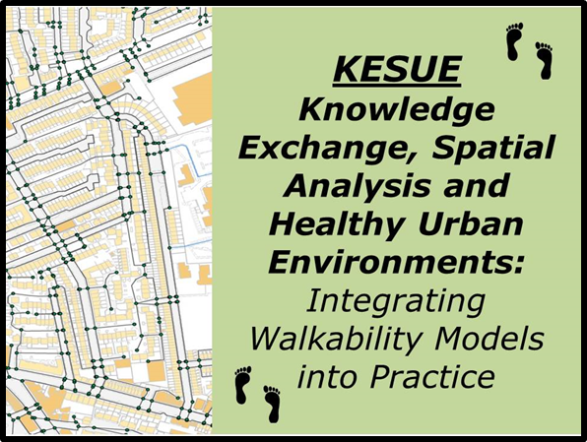
Walkability Workshop
10.00-1.00
Friday 22nd March
Hove Town Hall

Places are free, but please register in advance with David Brindley
(Public Health Team, Brighton & Hove City Council)
Tel: 01273 290510
e-mail: David.Brindley@brighton-hove.gov.uk

Knowledge Exc

This half-day workshop will present the findings of a year-long project, Knowledge Exchange, Spatial Analysis and Healthy Urban Environments (KESUE). This has explored a range of tools that can be used to map and analyse accessibility or walkability with the aim of supporting a stronger evidence base for Healthy Urban Planning.
The purposes of the workshop are to:
- Explore the role of the built environment in influencing physical activity and health;
- Discuss how to measure and assess the walkability and accessibility of the built environment;
- Describe the activities under the KESUE project and highlight a range of case studies in how it has been used;
- Explore potential applications of these tools in promoting active travel in Brighton.
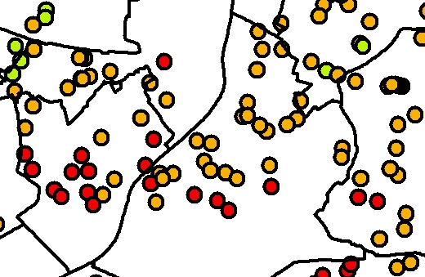
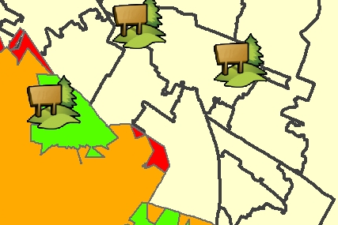
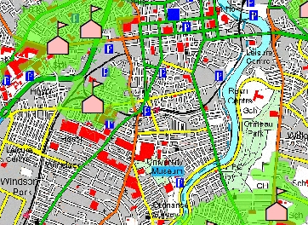
KESUE is being undertaken by the School of Planning, Architecture and Civil Engineering and the Centre for Excellence in Public Health at Queen’s University Belfast, in conjunction with a range of partners that includes the Economic and Social Research Council (ESRC), Dept. of Regional Development, Belfast City Council, Derry City Council, the Public Health Agency and Belfast Healthy Cities.

For more information see: http://www.qub.ac.uk/research-centres/KnowledgeExchangeSpatialAnalysisandHealthyUrbanEnvironments/


Walkability Workshop
Hove Town Hall
Friday 22nd March 2013

Outline Programme
1000: | Introductions and purposes of the workshop
1010: | Background to the KESUE project
1030: | Understanding walkability, physical activity and built environment interventions  Questions and discussion
1100: | Developing the Real Walkable Network (RWN)  Questions and discussion
1120 | Break
1145: | Walkability analysis using the RWN: Case Studies and Applications  Questions and discussion
1210 | Discussion:  What are the lessons, priorities and potential applications for Brighton?
1300 | Close

The project will be led by Professor Geraint Ellis, of the School of Planning, Architecture and Civil Engineering at Queen’s University Belfast.
(see: http://pure.qub.ac.uk/portal/en/persons/geraint-ellis(baeda811-7a40-4a2c-b18f-531c31a07cd7).html )

